1. For a Given BST, Write a code to implement the following:
2. Insert a given node
3. Delete a given Node
4. Using the concept of minimum cost spanning tree, find the minimum length of the LAN wire required to connect the buildings shown in the following Graph:

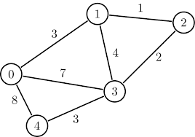

1. Google Map provides us the best possible route from a source A to source B. Write a code to implement a similar approach for the Graph Given Below.



1. An efficient method of searching a particular data is when the elements are stored in Balanced BST. The balancing factor does not allow the tree to grow beyond a certain height. Implement the insertion and deletion in such a tree
2. In a Chess board of 8X8 squares, write a code to place 8 Queens in such a way that no two queens are attacking each other.